STREETSMART — DIGITAL INFORMAL TRADE PERMIT SYSTEM

NOTE: Names used here are fictional, used for demonstration purposes to showcase my skills and understanding.

## DOCUMENT CONTROL & VERSION HISTORY

**Document Control**

|  |  |
| --- | --- |
| **Document Property** | **Value** |
| **Project Name** | StreetSmart — Digital Informal Trade Permit System |
| **Document Type** | Full SDLC / Business Analysis Artifact |
| **Author** | Bheki Mogola (Business Analyst) |
| **Reviewer** | [Paul Ndzimande] (Head of Business Analysis) |
| **Status** | Final Draft for Deployment |

**Version History**

|  |  |  |  |
| --- | --- | --- | --- |
| **Version** | **Date** | **Author** | **Description of Changes** |
| **1.0** | 2025-10-01 | B. Mogola | Initial Draft: Problem Statement, Root Cause Analysis, and High-Level Scope. |
| **2.0** | 2025-12-01 | B. Mogola | Added System Design (ERD/DFD), Pilot Implementation Plan, and Test Cases. |
| **2.1** | 2025-12-09 | B. Mogola | Final Review: Added Deployment Readiness Checklist, Glossary, and Sign-Offs. |

## TABLE OF CONTENTS

1. [Phase 1: Planning & Requirement Analysis](https://www.google.com/search?q=%23phase-1-planning--requirement-analysis)
2. [Phase 2: System Design](https://www.google.com/search?q=%23phase-2-system-design)
3. [Phase 3: Development](https://www.google.com/search?q=%23phase-3-development-simplified)
4. [Phase 4: Testing](https://www.google.com/search?q=%23phase-4-testing)
5. [Phase 5: Deployment](https://www.google.com/search?q=%23phase-5-deployment)
6. [Phase 6: Maintenance & Support](https://www.google.com/search?q=%23phase-6-maintenance--support)

## PHASE 1 — PLANNING & REQUIREMENT ANALYSIS

* 1. **Project Charter**

|  |
| --- |
| **Project Name:** StreetSmart — Digital Informal Trade Permit System |
| **Project Sponsor:** Thaba Chweu Local Municipality (Director of Local Economic Development) |
| **Business Analyst:** Bheki Mogola |
| **Target Delivery (MVP):** 10–12 Weeks (Target Go-Live: March 1, 2026) |
| **Core Problem:** Inefficiency in manual permitting leading to long vendor queues, cash handling risks, and enforcement difficulties. |
| **High-Level Scope:**   * 1. Vendor Registration (USSD for feature phones + Web Portal).   2. Digital Permit Application & Payment (Daily/Monthly).   3. QR Code Generation for Permits.   4. Inspector Mobile App for Verification.   5. Admin Dashboard for Revenue Reporting. |

**1.2 Problem Statement**

Thaba Chweu Municipality currently uses a manual, paper-based permit system for informal traders. This leads to extreme queue times (avg. 3 hours), unreliable record-keeping, cash-related fraud, lost municipal revenue, slow enforcement, poor vendor experience, and limited visibility of trading compliance. The municipality requires a digital system (USSD + Web + QR) to increase efficiency, secure revenue, and support inspectors with real-time verification.

**1.3 Root Cause Analysis**

**The 5-Whys Summary:**

1. **Why are vendors angry?** They queue for hours to obtain permits.
2. **Why do they queue?** The issuance process is manual and paper-based.
3. **Why is it manual?** Payments are strictly cash-based at the office.
4. **Why is it cash-based?** There is no digital system to accept remote payments.
5. **Why is there no system?** Lack of budget and historical low prioritization of informal trade management.

**Fishbone Analysis:**

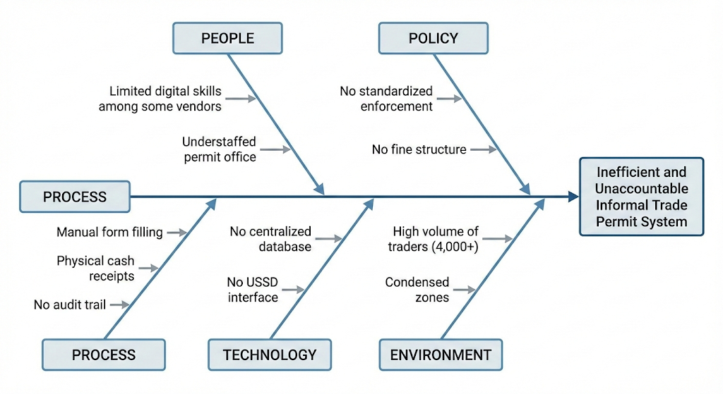

**1.4 Feasibility Study**

* **Operational Feasibility:** High. System caters to ~4,000 vendors. USSD ensures accessibility for non-smartphone users. Inspectors already possess municipal-issued Android devices.
* **Technical Feasibility:** High. Cloud hosting (Azure/AWS) is available. QR generation is a standard technology. Integration with Payment Gateways (PayFast) is standard.
* **Economic Feasibility:**
  + **Estimated Cost:** R1,200,000 (Dev + Year 1 Ops).
  + **Revenue Recovery:** Projected R8,000,000+ in previously lost fees.
  + **ROI:** Highly Positive.
* **Schedule Feasibility:** MVP is achievable within 12 weeks using Agile sprints.

**1.5 Business Requirements Document (BRD)**

**Business Needs:**

1. Eliminate physical queuing for permits.
2. Ensure 100% of permits are digitally verifiable to reduce fraud.
3. Transition 90% of payments from cash to digital channels.
4. Provide Finance with automated daily revenue reconciliation.

**Business Rules:**

1. **Daily Permit:** Valid for 24 hours from time of purchase (00:00 to 23:59).
2. **Monthly Permit:** Valid for 30 calendar days.
3. **Verification:** Vendor must present a valid QR code (digital or printed) upon inspection.
4. **Zones:** Vendors must select a specific trading zone; permits are not transferable between zones.

**1.6 Software Requirements Specification (SRS)**

**Functional Requirements (FR):**

* **FR-01:** System must allow vendors to register via USSD (*120*555#) or Web Portal.
* **FR-02:** System must authenticate vendors using Mobile Number + OTP.
* **FR-03:** System must allow selection of Permit Type (Daily/Monthly) and Zone.
* **FR-04:** System must process payments via Card or Instant EFT.
* **FR-05:** System must generate a unique, encrypted QR code upon payment success.
* **FR-06:** Inspector App must scan QR codes and return status (Valid/Expired/Fake).
* **FR-07:** Admin Dashboard must display total revenue and active permits per zone.
* **FR-08:** System must log all actions for audit purposes.

**Non-Functional Requirements (NFR):**

* **Security:** Full POPIA compliance; Data encryption at rest and in transit.
* **Performance:** QR Verification scan must return result in < 1 second.
* **Scalability:** Architecture must support 4,000+ concurrent users.
* **Availability:** 99.9% Uptime SLA during trading hours (06:00 – 18:00).

**1.7 Stakeholders**

|  |  |  |
| --- | --- | --- |
| **Stakeholder** | **Role** | **Responsibility** |
| **Vendors** | End User | Register, Pay, Trade. |
| **Inspectors** | Enforcement | Verify permits, Log violations. |
| **Permit Office** | Admin | Manage zones, Resolve disputes. |
| **Finance Dept** | Reporting | Reconcile bank deposits vs. system logs. |
| **IT Team** | Technical | Maintenance, Server Uptime. |

**RACI Table**

|  |  |  |  |  |  |
| --- | --- | --- | --- | --- | --- |
| **Process / Activity** | **Vendors (End User)** | **Inspectors (Enforcement)** | **Permit Office (Admin)** | **Finance Dept (Reporting)** | **IT Team (Technical)** |
| **1. Registration & Onboarding** | **R** | I | **A** | I | I |
| **2. Permit Payment Processing** | **R** | I | I | **A** | C |
| **3. Conducting Trading Activities** | **R** / **A** | I | I | - | - |
| **4. Zone & Location Management** | I | C | **R** / **A** | - | I |
| **5. Permit Verification (Field)** | I | **R** | **A** | - | - |
| **6. Logging Violations** | I | **R** | **A** | - | - |
| **7. Dispute Resolution** | C | C | **R** / **A** | I | - |
| **8. Financial Reconciliation** | - | - | I | **R** / **A** | C |
| **9. System Maintenance & Uptime** | I | I | C | I | **R** / **A** |

**1.8 Stakeholder Engagement Log: Challenges, Needs & Improvements**

|  |  |  |  |
| --- | --- | --- | --- |
| **Stakeholder Group** | **Key Challenges (Pain Points)** | **Specific Needs (Requirements)** | **Suggested Improvement Areas** |
| **Informal Traders (Vendors)** | "I lose 3 hours of sales standing in line."  "I get robbed carrying cash to the office." | **Convenience & Safety:** Ability to pay from anywhere without cash. | **USSD Integration:** Ensure system works on non-smartphones as data is expensive. |
| **Enforcement (Inspectors)** | "People show me fake paper receipts."  "I cannot check if a permit was shared." | **Instant Verification:** A tool to validate permits immediately in the field. | **Offline Mode:** The scanner must work even if the network is down in remote zones. |
| **Finance Department** | "Reconciling thousands of R45 cash payments is a nightmare."  "Money goes missing." | **Auditability:** Automated logs that match bank deposits. | **Dashboard Reporting:** Auto-generated daily reports (CSV/PDF) to replace manual counting. |
| **Permit Office (Admin)** | "We don't know which zones are overcrowded until we go there." | **Visibility:** Real-time data on how many traders are in each zone. | **Zone Capping:** System should automatically stop selling permits when a zone is full. |

**1.8 Risk Log**

|  |  |  |
| --- | --- | --- |
| **Risk** | **Impact** | **Mitigation Strategy** |
| **USSD Provisioning Delay** | High | Use temporary "Long Code" SMS bot if Short Code is delayed. |
| **Payment Gateway Downtime** | High | Implement secondary gateway failover (switch from PayFast to Yoco). |
| **Low Vendor Adoption** | Medium | Launch "StreetSmart Ambassadors" program to train vendors on-site. |
| **Data Privacy Breach** | Critical | Implement strict role-based access control (RBAC) and encryption. |
|  |  |  |

## PHASE 2 — SYSTEM DESIGN

**2.1 AS-IS Swimlane Process (Current State)**

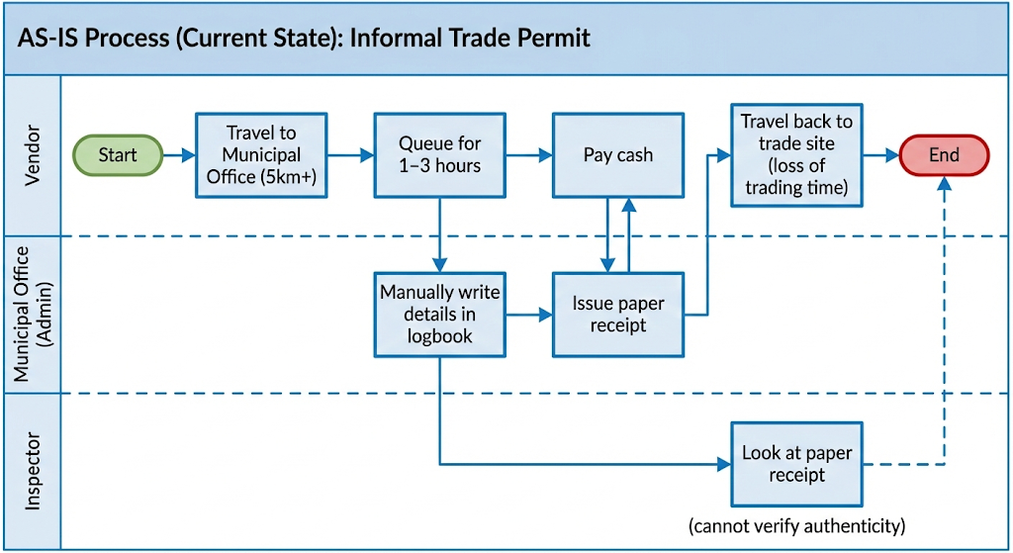

**2.2 TO-BE Swimlane Process (Future State)**

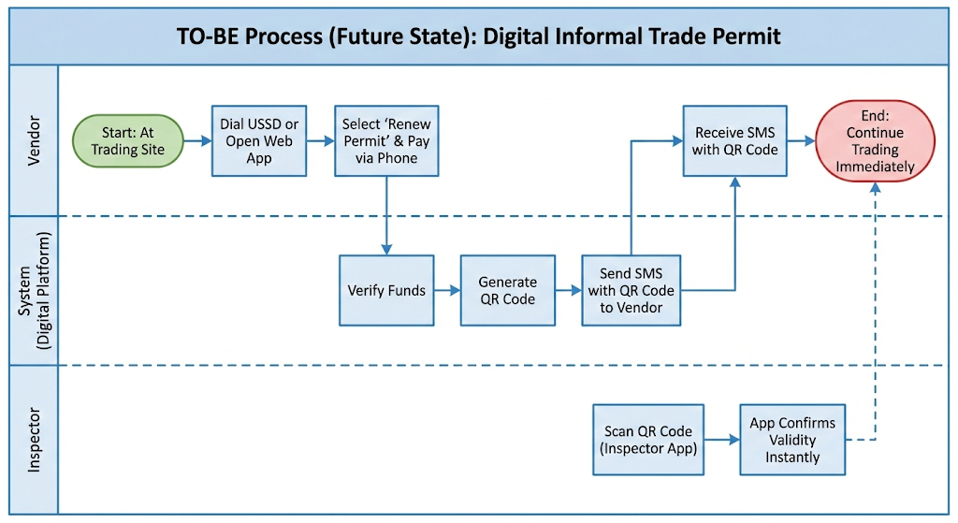

**2.3 High-Level System Architecture**

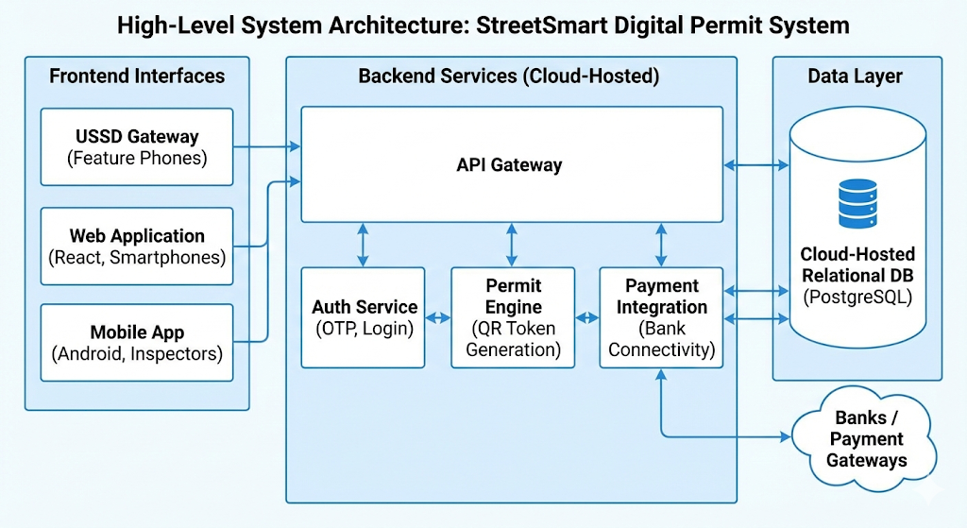

**2.4 Database Design (Simplified Entities)**

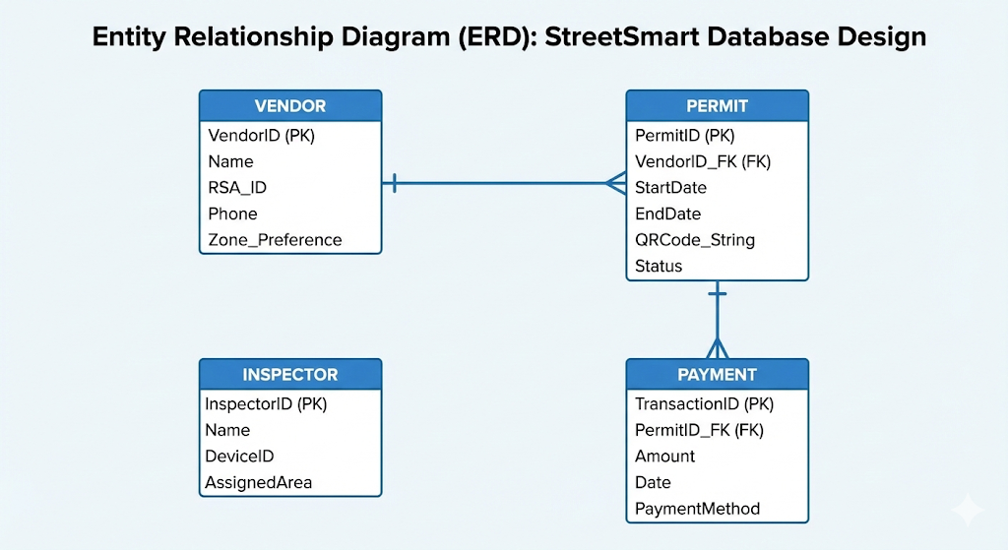

**2.5 Data Flow Diagrams**

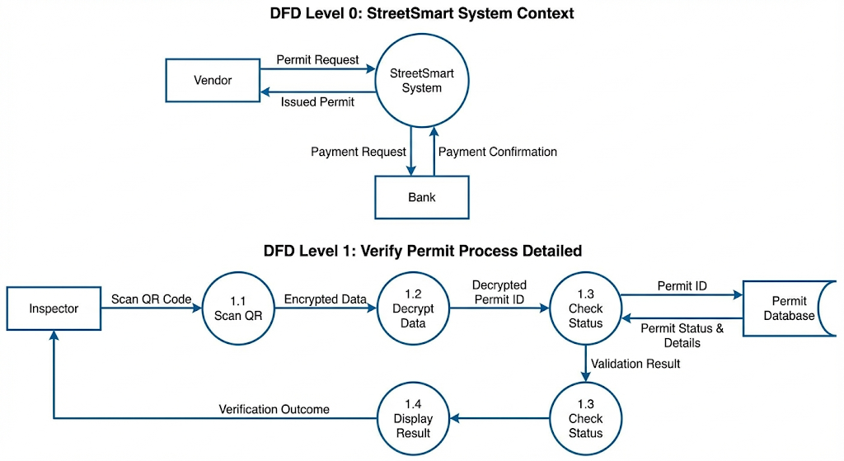

**2.6 Site Map**

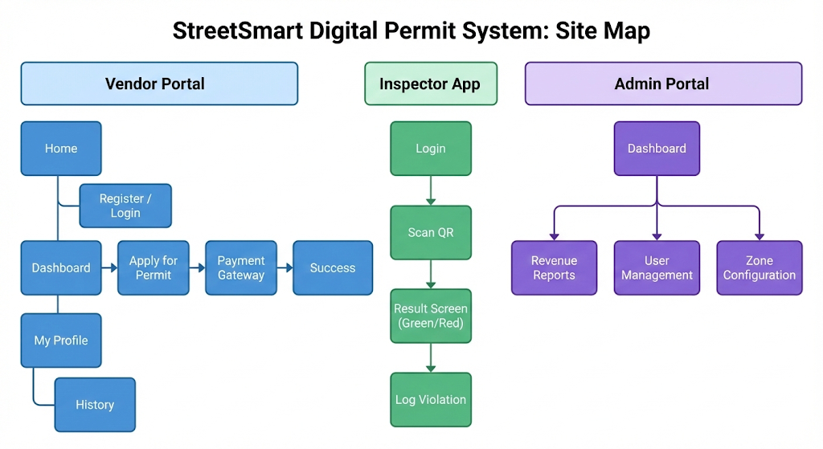

**2.7 Wireframes (Conceptual)**

* **Screen 1 (Vendor - USSD):** Text menu: "1. Register, 2. Buy Permit, 3. Check Status".
* **Screen 2 (Vendor - Web):** Simple form with "Pay Now" button and QR display area.
* **Screen 3 (Inspector - Mobile):** Large camera viewfinder. Success popup shows Vendor Photo & Name.

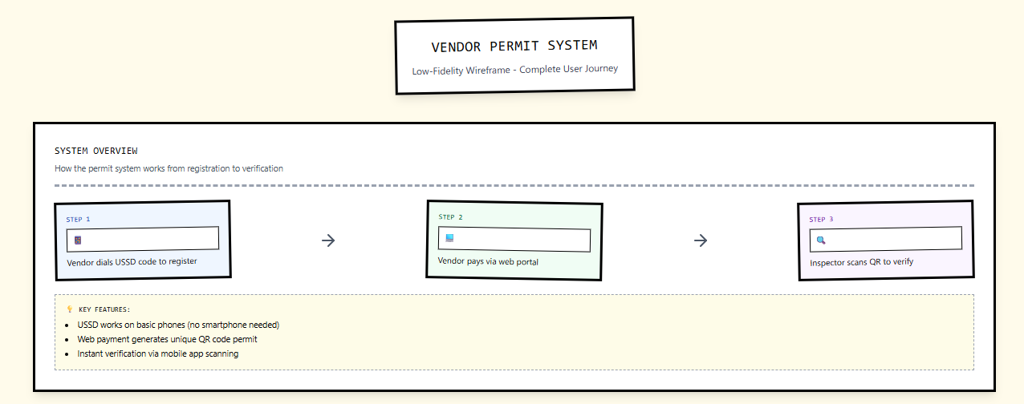

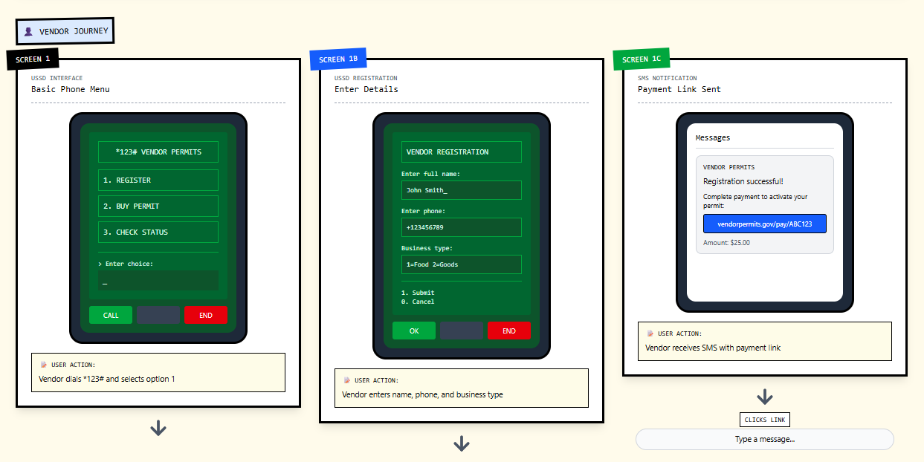

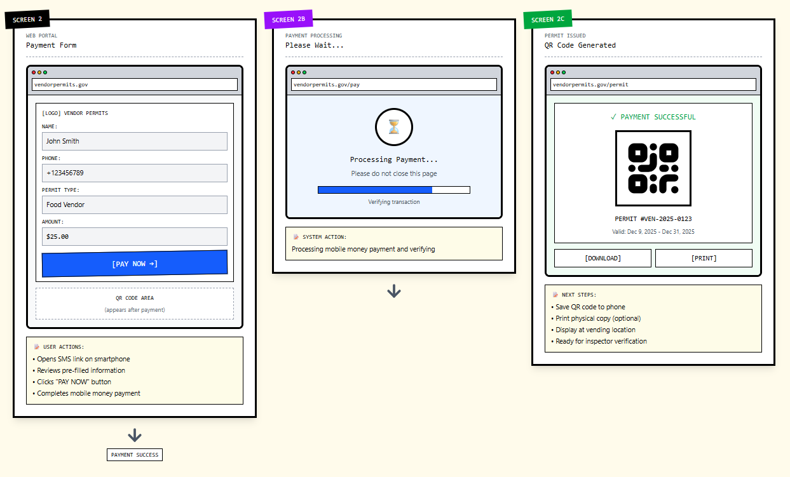

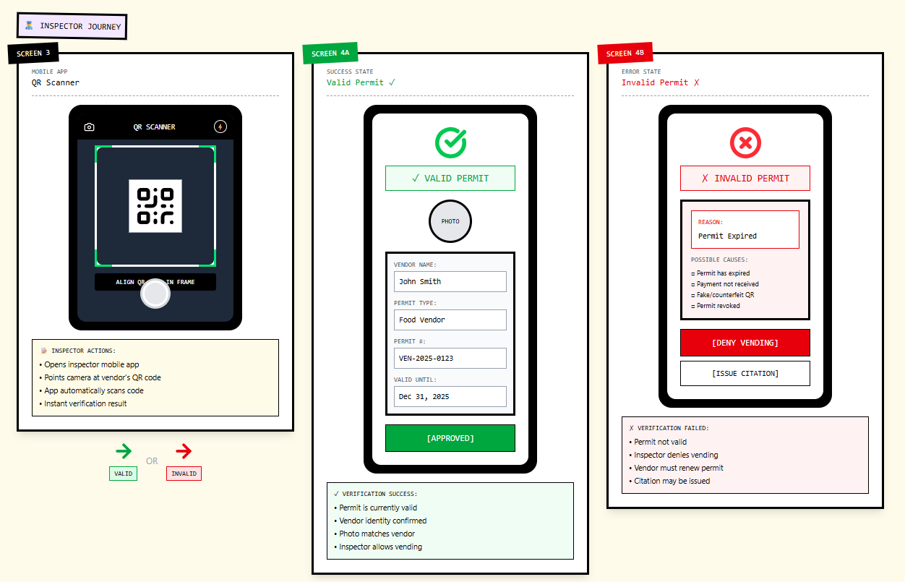

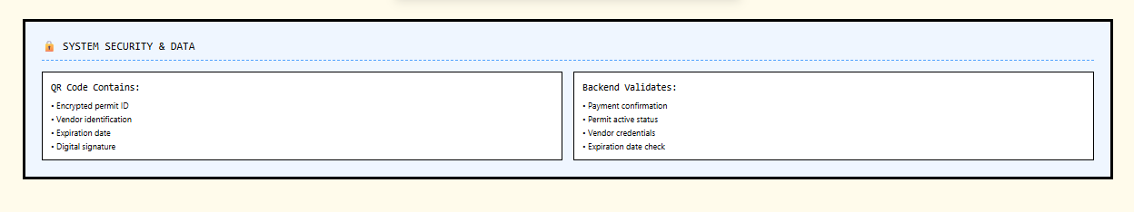

**2.8 Use Case Diagram**

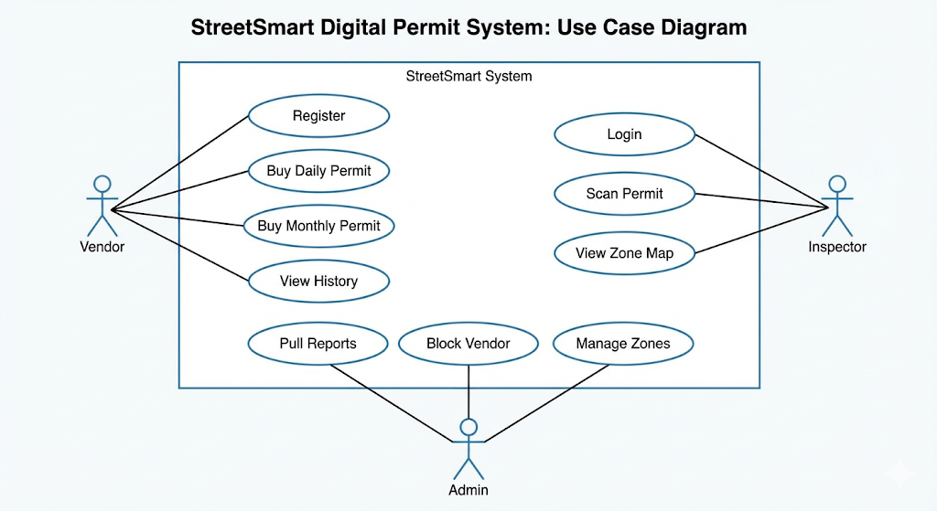

**2.9 User Stories**

* **Vendor:** "As a **Vendor**, I want to **register via USSD**, so that **I don't need a smartphone to trade legally**."
* **Vendor:** "As a **Vendor**, I want to **receive an SMS notification**, so that **I have proof of payment even if my data runs out**."
* **Inspector:** "As an **Inspector**, I want to **scan QR codes**, so that **I can verify permits in under 5 seconds**."
* **Admin:** "As a **Finance Admin**, I want to **download daily CSV reports**, so that **I can reconcile the bank account**."

**2.10 User Acceptance Criteria (AC)**

**AC-01: Vendor USSD Registration**

**User Story:** "As a Vendor, I want to register via USSD, so that I don't need a smartphone to trade legally."

* **Scenario 1: Successful Registration**
  + **Given** the user dials *120*555# and selects "Register".
  + **When** they enter a valid 13-digit RSA ID and a valid Name.
  + **Then** the system must create a new Vendor record in the database.
  + **And** the user must receive an SMS confirmation within 60 seconds.
  + **And** the system must auto-login the user for the current session.
* **Scenario 2: Data Validation**
  + **Given** the user is on the input screen.
  + **When** they enter an ID with non-numeric characters or incorrect length (<13 digits).
  + **Then** the system must display an error: "Invalid format. Retry."
  + **And** the user must be allowed 3 attempts before the session terminates.

**AC-02: Offline Payment Proof**

**User Story:** "As a Vendor, I want to receive an SMS notification, so that I have proof of payment even if my data runs out."

* **Scenario 1: SMS Delivery Trigger**
  + **Given** a payment transaction (Card or EFT) has returned a "Success" status from the Gateway.
  + **When** the database updates the Permit Status to "Active".
  + **Then** the SMS Gateway must trigger a message to the registered mobile number.
  + **And** the SMS content must include: Permit ID, Expiry Date, and Zone Name.
* **Scenario 2: Low Balance / Transaction Fail**
  + **Given** the payment fails due to insufficient funds.
  + **When** the user is returned to the menu.
  + **Then** NO permit generated.
  + **And** the user receives an on-screen notification (USSD flash message) explaining the failure.

**AC-03: Rapid Inspector Verification**

**User Story:** "As an Inspector, I want to scan QR codes, so that I can verify permits in under 5 seconds."

* **Scenario 1: Scan Performance**
  + **Given** the Inspector App is open in camera mode.
  + **When** the camera focuses on a StreetSmart QR code.
  + **Then** the app must decode and display the result (Green/Red screen) in less than 1.0 seconds.
* **Scenario 2: Offline Verification**
  + **Given** the Inspector's device has no 4G/LTE signal.
  + **When** a valid QR code is scanned.
  + **Then** the app must successfully validate the cryptographic signature locally.
  + **And** display the Vendor Name and Permit Expiry Date.

**AC-04: Financial Reconciliation Reporting**

**User Story:** "As a Finance Admin, I want to download daily CSV reports, so that I can reconcile the bank account."

* **Scenario 1: Report Contents**
  + **Given** the Admin is on the "Reports" tab.
  + **When** they select a date range and click "Export CSV".
  + **Then** the downloaded file must contain columns: Transaction ID, Date, Vendor ID, Amount, Payment Method, and Zone.
  + **And** the sum of the "Amount" column must match the Payment Gateway settlement total.

**2.11 User Journeys & Personas**

**Persona A: "Gogo Sarah" (The Informal Trader)**

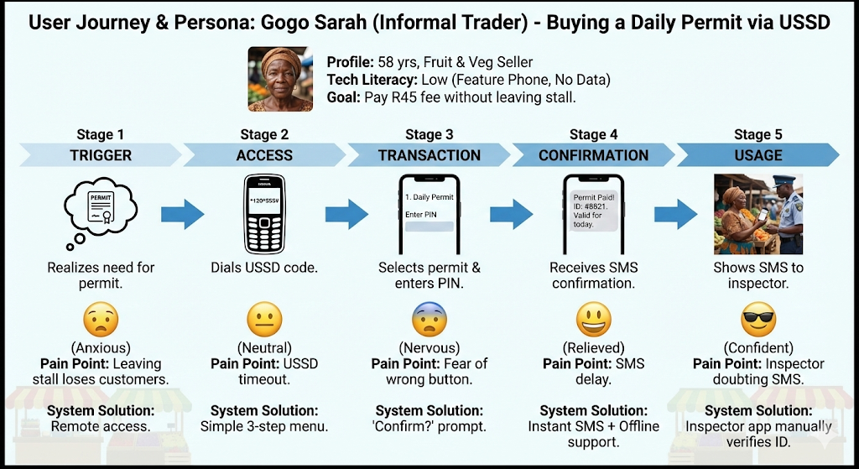

**Persona B: "Officer John" (The Inspector)**

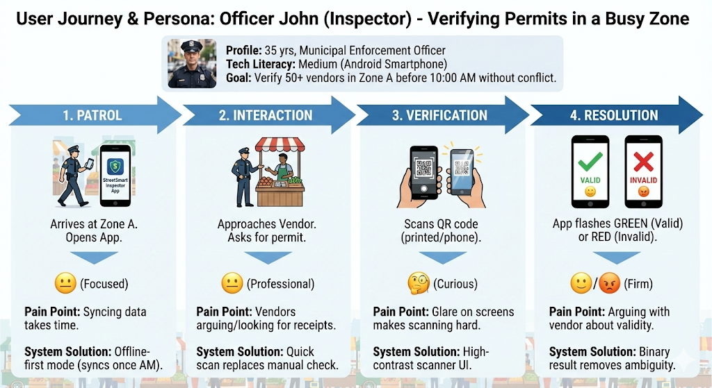

**Persona C: "Thabo" (The Finance Admin)**

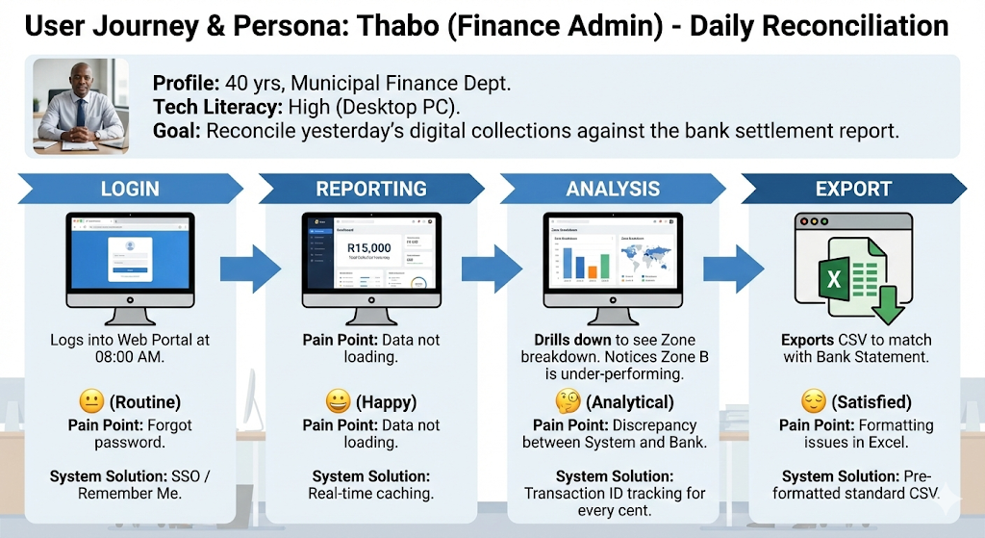

## PHASE 3 — DEVELOPMENT

**3.1 Technology Stack**

* **Frontend:** HTML5/React (Web), USSD (GSM Standard), Android (Native/Kotlin).
* **Backend:** Node.js or Python (Django).
* **Database:** PostgreSQL.
* **Hosting:** AWS or Azure Cloud.

**3.2 Coding Standards**

* Code must be documented clearly.
* APIs must follow RESTful standards.
* Security tokens (JWT) used for all API calls.

**3.3 Integration Points**

* **SMS Gateway:** Twilio or BulkSMS.
* **Payment Gateway:** PayFast or Ozow.
* **USSD Aggregator:** Vodacom/MTN integration.

**3.4 Stakeholder Demo Script**

**Objective:** To demonstrate the end-to-end flow to Municipal Leadership (Mayor/Director) to secure approval for the Pilot.

|  |  |  |  |  |
| --- | --- | --- | --- | --- |
| **Step** | **Time** | **Actor** | **Action** | **Narration / Talking Point** |
| **1** | 00:00 | Vendor (Phone) | Dials *120*555# | "Notice how the system works on a basic feature phone. No data required." |
| **2** | 05:00 | Vendor (Phone) | Selects "Buy Permit" > "Zone A" | "The system immediately checks Zone A capacity. It enforces our overcrowding rules automatically." |
| **3** | 10:00 | System | SMS Received | "The vendor receives a digital receipt instantly. No paper, no cash handling at the office." |
| **4** | 15:00 | Inspector (App) | Scans Demo QR Code | "Now, look at the Inspector's tablet. It scans in under 1 second." |
| **5** | 17:00 | Inspector (App) | Result: Green Tick | "The Green screen prevents arguments. It is binary: Valid or Invalid." |
| **6** | 20:00 | Admin (Web) | Refreshes Dashboard | "Finally, Finance sees that money immediately in the dashboard. Reconciliation is automatic." |

## PHASE 4 — TESTING

**4.1 Pilot Implementation Plan**

**Objective:** To test the system in the "Real World" with a limited scope before full rollout.

**4.1.1 Pilot Scope**

* **Duration:** 5 Working Days (Monday – Friday).
* **Location:** Zone A (Taxi Rank Only).
* **Participants:**
  + **Vendors:** 20 pre-selected "Friendly" vendors (mix of youth and elderly).
  + **Inspectors:** 2 Senior Inspectors.
  + **Support:** 1 Technical Support Officer on-site.

**4.1.2 Success Metrics (Pilot Exit Criteria)**

* **Adoption:** 80% of pilot vendors successfully buy a permit without assistance by Day 3.
* **Performance:** QR Scan average time remains under 2 seconds in field conditions.
* **Reliability:** Zero system crashes during the 5-day period.
* **Finance:** 100% reconciliation match between Bank Statement and System Logs.

**4.1.3 Logistics & Setup**

1. **Onboarding Day (Monday Morning):**
   * Gather 20 vendors.
   * Assist them in registering on their own phones.
   * Issue R50 "Test Credit" vouchers (so they don't spend their own money for the test).
2. **Daily Routine:**
   * 08:00: Vendors buy daily permits.
   * 10:00: Inspectors walk the beat and scan codes.
   * 16:00: Debrief meeting with Inspectors (What went wrong?).

**4.1.4 QA Instructions for Pilot**

* **Observation:** QA Team should not interfere. Watch from a distance to see if vendors struggle with the USSD menu.
* **Network Stress:** QA must test scanning in "Dead Spots" (areas in the Taxi Rank with poor signal) to verify Offline Mode.
* **Exception Handling:** QA must deliberately ask one vendor to try buying a permit for a "Full Zone" to see if the system blocks them in a real-world scenario.

**4.2 Test Types**

**Unit Testing:** Developers test individual functions in isolation, such as the Fee Calculation Logic (ensuring R45 is always charged for Daily Permits) and ID Validation Regex.

**Integration Testing:** Testing the handshakes between external systems, specifically ensuring the USSD Gateway successfully triggers the Payment Processor (PayFast) and receives a success token back.

**System Testing:**End-to-end validation of the entire lifecycle: A user registers via USSD, pays, receives a QR code, and an Inspector successfully scans that code to verify data consistency across all platforms.

**4.3 UAT Test Cases (Mock Data)**

**Section A: Vendor USSD Interface (Feature Phones)**

*Target User: Vendors without smartphones*

|  |  |  |  |  |  |
| --- | --- | --- | --- | --- | --- |
| **Test ID** | **Scenario** | **Pre-Conditions** | **Test Steps** | **Expected Result** | **Pass/Fail** |
| **TC-U01** | **New Vendor Registration (Success)** | User is not registered. Mobile network active. | 1. Dial *120*555#.  2. Select "Register".  3. Enter valid RSA ID.  4. Enter Name/Surname. | System displays "Registration Successful. Welcome [Name]" and sends SMS confirmation. | **Pass** |
| **TC-U02** | **Invalid ID Handling** | User is on Registration screen. | 1. Enter ID 9999 (Too short).  2. Submit. | System returns error: "Invalid ID Format. Please enter 13 digits." | **Pass** |
| **TC-U03** | **Buy Daily Permit (Insufficient Funds)** | User registered. Wallet balance R0.00. | 1. Dial *120*555#.  2. Select "Buy Permit".  3. Select "Daily (R45)". | System displays "Insufficient Funds. Please load voucher or link card." | **Pass** |
| **TC-U04** | **Zone Selection Validation** | User has funds. | 1. Select "Buy Permit".  2. Select "Zone A (Taxi Rank)".  3. Confirm Payment. | System deducts funds and SMSs a text-based Permit reference (#ZONE-A-445). | **Pass** |
| **TC-U05** | **Network Timeout Handling** | Network signal weak. | 1. Initiate transaction.  2. Wait 60 seconds without input. | System should terminate session securely without deducting funds. | **Pass** |

**Section B: Vendor Web Portal (Smartphones/Desktop)**

*Target User: Vendors with smartphones printing QR codes*

|  |  |  |  |  |  |
| --- | --- | --- | --- | --- | --- |
| **Test ID** | **Scenario** | **Pre-Conditions** | **Test Steps** | **Expected Result** | **Pass/Fail** |
| **TC-W01** | **Monthly Permit Purchase** | User logged in. | 1. Dashboard > "Apply for Permit".  2. Select "Monthly".  3. Pay via Card (Mock Gateway). | Payment success screen appears. QR Code is generated and displayed immediately. | **Pass** |
| **TC-W02** | **QR Code Download** | Permit purchased. | 1. Go to "My Permits".  2. Click "Download PDF". | PDF downloads containing the QR Code and Vendor Name. | **Pass** |
| **TC-W03** | **Duplicate Account Check** | ID already exists in DB. | 1. Try to register with existing ID.  2. Submit. | Error: "User already exists. Please Login or Reset Password." | **Pass** |

**Section C: Inspector Mobile App**

*Target User: Municipal Enforcement Officers*

|  |  |  |  |  |  |
| --- | --- | --- | --- | --- | --- |
| **Test ID** | **Scenario** | **Pre-Conditions** | **Test Steps** | **Expected Result** | **Pass/Fail** |
| **TC-I01** | **Scan Valid Permit** | Inspector logged in. | 1. Tap "Scan".  2. Point camera at valid QR.  3. Wait for focus. | App beeps. Screen turns GREEN. Shows: Vendor Name, Zone, and "VALID" status. | **Pass** |
| **TC-I02** | **Scan Expired Permit** | Permit expired yesterday. | 1. Tap "Scan".  2. Point camera at expired QR. | App vibrates. Screen turns RED. Shows: "EXPIRED [Date]". | **Pass** |
| **TC-I03** | **Scan Fake/Foreign QR** | A random QR code (ie. Coke bottle). | 1. Tap "Scan".  2. Point camera at random QR. | App displays "INVALID FORMAT" or "Permit Not Found". | **Pass** |
| **TC-I04** | **Offline Scanning Mode** | Mobile Data turned OFF. | 1. Turn off Data.  2. Scan a valid QR code (cached). | App should still verify signature and return Valid/Invalid based on encrypted string. | **Pass** |
| **TC-I05** | **Log Violation** | Scanned Invalid Permit. | 1. On "Invalid" screen, tap "Log Fine".  2. Enter Reason "Trading without permit".  3. Submit. | Violation logged to Admin Dashboard. Inspector sees "Fine Issued" confirmation. | **Pass** |

**Section D: Admin Dashboard**

*Target User: Finance & Permit Office*

|  |  |  |  |  |  |
| --- | --- | --- | --- | --- | --- |
| **Test ID** | **Scenario** | **Pre-Conditions** | **Test Steps** | **Expected Result** | **Pass/Fail** |
| **TC-A01** | **Real-time Revenue View** | 3 Vendors just bought permits. | 1. Login as Admin.  2. Refresh "Today's Revenue". | Total Revenue increases by exactly (3 * Permit Cost). | **Pass** |
| **TC-A02** | **Zone Cap Enforcement** | Zone A capacity set to 100. | 1. Simulate 100 active permits in Zone A.  2. Try to buy 101st permit (via simulator). | System prevents purchase. Status: "Zone Full". | **Pass** |

**4.4 UAT Feedback Log (mock data)**

**Purpose:** To capture subjective feedback, usability concerns, and suggestions from non-technical stakeholders (Vendors, Inspectors) during the trial run.

**Feedback Types:**

* **Positive:** Features users loved.
* **Observation:** Neutral comments on flow/design.
* **Suggestion:** Ideas for improvement.
* **Complaint:** Usability frustrations.

|  |  |  |  |  |  |  |  |
| --- | --- | --- | --- | --- | --- | --- | --- |
| **ID** | **Date** | **Reviewer Role** | **Feature / Screen** | **Feedback Type** | **Comments / Description** | **Priority** | **Response / Action Plan** |
| **FB-01** | 2025-12-09 | Vendor (Elderly) | USSD Registration | Complaint | "The text goes away too fast on the USSD menu. I don't have time to read the terms." | Medium | **Action:** Investigate extending USSD timeout or shortening text descriptions. |
| **FB-02** | 2025-12-09 | Vendor (Youth) | Web Portal | Suggestion | "Can we pay using Capitec Pay or Apple Pay? Entering card numbers takes too long." | Low | **Action:** Added to "Future Enhancements" list for Phase 2. |
| **FB-03** | 2025-12-10 | Inspector | Scanning App | Positive | "The green screen for valid permits is great. I don't even have to read the text, I just see green and move on." | - | **Action:** None. Design validated. |
| **FB-04** | 2025-12-10 | Finance Admin | Dashboard | Observation | "The 'Export CSV' button is hidden inside the settings menu. It should be on the main page." | High | **Action:** Move Export button to the top right of the main dashboard header. |
| **FB-05** | 2025-12-11 | Inspector | Violation Logging | Complaint | "The keyboard covers the 'Submit' button on my small Samsung phone when I try to type a fine reason." | High | **Action:** UI Adjustment required for small viewports. Pass to Dev team. |
| **FB-06** | 2025-12-11 | Vendor | USSD Payment | Suggestion | "I forgot to save the SMS with my permit number. Can I dial a number to see my last permit?" | Medium | **Action:** Ensure *120*555# has a "View My Permit" option as the first item if a valid permit exists. |

**4.4 UAT Defect / Bug Report Log (mock data)**

**Purpose:** To document specific technical failures where the system did not perform as per the Functional Requirements (SRS).

**Severity Levels:**

* **Critical:** System unusable / Data loss (Showstopper).
* **High:** Major feature broken, workaround difficult.
* **Medium:** Feature broken, workaround exists.
* **Low:** Cosmetic / Spelling error.

|  |  |  |  |  |  |  |  |  |  |  |
| --- | --- | --- | --- | --- | --- | --- | --- | --- | --- | --- |
| **Defect ID** | **Date Found** | **Found By** | **Module** | **Severity** | **Summary** | **Steps to Reproduce** | **Expected Result** | **Actual Result** | **Status** | **Assigned To** |
| **DEF-001** | 2025-12-09 | QA Team | USSD | Critical | **Registration fails for IDs starting with '00' (Year 2000)** | 1. Dial USSD.  2. Register.  3. Enter ID: 000512... | System accepts ID. | System returns "Invalid Date of Birth" error. Likely interpreting '00' incorrectly. | **Open** | Backend Dev |
| **DEF-002** | 2025-12-09 | Inspector John | Android App | High | **App crashes on "Back" button** | 1. Open Inspector App.  2. Scan QR.  3. View Result.  4. Press physical 'Back' button on phone. | Return to camera view. | App closes completely (Crash). | **In Progress** | Mobile Dev |
| **DEF-003** | 2025-12-10 | Admin Thabo | Dashboard | Medium | **Revenue calculation rounding error** | 1. Purchase 3 permits at R45.50.  2. Check Dashboard Total. | Total: R136.50. | Total shows R136.00 (Seems to be flooring decimals). | **Open** | Database Dev |
| **DEF-004** | 2025-12-10 | QA Team | Web Portal | Low | **Typo in 'Success' message** | 1. Complete payment. | "Payment Successful". | Text reads "Payment Succefull" (Spelling). | **Fixed** | Frontend Dev |
| **DEF-005** | 2025-12-11 | Vendor | USSD | High | **OTP SMS delay > 5 minutes** | 1. Request OTP for login. | Receive SMS within 30 seconds. | SMS received 7 minutes later. Session timed out by then. | **Investigating** | API Team |

## PHASE 5 — DEPLOYMENT

**5.1 Deployment Readiness Checklist (Go/No-Go Gate)**

**Target Go-Live: March 1, 2026**

**Purpose: To verify all conditions are met before pushing the application to the Live Production Environment.**

|  |  |  |  |  |
| --- | --- | --- | --- | --- |
| **Category** | **ID** | **Criteria** | **Owner** | **Status** |
| **Quality Assurance** | **DR-01** | **Code Freeze: All feature coding halted 48 hours prior to launch.** | **Dev Lead** |  |
|  | **DR-02** | **Critical Defect Zero: No active "Critical" or "High" severity bugs in Defect Log.** | **QA Lead** |  |
|  | **DR-03** | **UAT Sign-off: Formal approval received from Vendor Representative.** | **B. Mogola** |  |
| **Infrastructure** | **DR-04** | **SSL Certificates: Valid HTTPS certificates installed on Web Portal and API.** | **IT Security** |  |
|  | **DR-05** | **Database Backup: Full backup of current Staging data taken. Recovery tested.** | **DB Admin** |  |
|  | **DR-06** | **Rollback Plan: Script to revert to previous version exists and is tested.** | **DevOps** |  |
|  | **DR-07** | **USSD Provisioning: Short code *120*555# is active and routed to Prod IP.** | **Network Team** |  |
| **Operations** | **DR-08** | **Support Scripts: Call Center agents provided with FAQ and USSD guides.** | **Ops Manager** |  |
|  | **DR-09** | **Inspector Training: 100% of inspectors have logged in at least once.** | **Field Lead** |  |

**Final Decision: GO / NO-GO**

**5.2 Data Migration**

* Export current (limited) Excel spreadsheets of vendors.
* Clean data (remove duplicates).
* Import "known" vendors into the new Database so they don't have to re-register.

**5.3 Training Plan**

* **Inspectors:** 1-day workshop on using the new Android Scanners.
* **Vendors:** Town hall meeting + distribution of pamphlets with USSD instructions.
* **Admins:** 2-hour session on using the Reporting Dashboard.

**5.4 Release Notes (v1.0)**

* **Launched:** USSD Channel (*120*555#).
* **Launched:** Inspector Verification App.
* **Note:** Web portal payment options limited to Credit Card for Week 1.

## PHASE 6 — MAINTENANCE & SUPPORT

**6.1 Support Model**

* **Level 1 (Call Center):** Help vendors reset PINs or explain USSD menu.
* **Level 2 (Technical):** Investigate transaction failures (money deducted but no permit).
* **Level 3 (Developer):** Fix code bugs or server outages.

**6.2 Service Level Agreement (SLA)**

* **Critical Bug (System Down):** Response within 30 mins, Resolve within 4 hours.
* **Major Bug (Payment failing):** Response within 1 hour, Resolve within 8 hours.
* **Minor Bug (Typos):** Resolve within 5 working days.

**6.3 Future Enhancements (Backlog)**

1. **Vendor Wallet:** Allow vendors to load credits (Prepaid) to avoid bank fees on every small transaction.
2. **Heatmap Analytics:** Show municipality which zones are busiest.
3. **WhatsApp Bot:** Add a WhatsApp channel alongside USSD.

## APPENDIX A: GLOSSARY OF TERMS

**Appendix A: Glossary of Terms**

|  |  |
| --- | --- |
| **Acronym / Term** | **Definition** |
| **API (Application Programming Interface)** | A set of rules that allows different software entities (like the Web Portal and the Database) to communicate with each other. |
| **GSM (Global System for Mobile)** | The standard digital cellular network used by mobile phones. |
| **JWT (JSON Web Token)** | A compact, URL-safe means of representing claims to be transferred between two parties. Used here for securely logging in users. |
| **MVP (Minimum Viable Product)** | The version of the system with just enough features to satisfy early customers and provide feedback for future development. |
| **POPIA (Protection of Personal Information Act)** | South Africa's data privacy law that governs how the municipality must store and protect vendor personal data. |
| **PostgreSQL** | An open-source relational database management system used to store vendor and permit records. |
| **RBAC (Role-Based Access Control)** | A security method that restricts system access based on a person's role (e.g., An Inspector cannot delete financial records). |
| **SDLC (Software Development Life Cycle)** | The process used by the software industry to design, develop, and test high-quality software. |
| **USSD (Unstructured Supplementary Service Data)** | A communications protocol used by GSM cellular telephones to communicate with the service provider's computers (e.g., *120*...#). |
| **SLA (Service Level Agreement)** | crucial contract or document defining the quality, availability, and responsibilities of a service provider for a customer (internal or external) |

## PROJECT SIGN-OFF

**Project Sign-Off**

I, the undersigned, acknowledge that I have reviewed the **StreetSmart — Digital Informal Trade Permit System (v2.1)** documentation.

I confirm that the **Business Requirements**, **System Design**, **Test Plan**, and **Deployment Criteria** documented herein accurately reflect the needs of the Thaba Chweu Local Municipality and approve the project to proceed to the next phase.

**Project Sponsor:**

**Name:** Clark Kent

**Title:** Director of Local Economic Development

**Date:** 01/01/2026

**Business Analyst:**

**Name:** Bheki Mogola

**Title:** Junior Business Analyst

**Date:** 01/01/2025

**Head of Business Analysis:**

Name: Paul Nzimande

Title: Head of Business Analysis

Date: 01/01/2025